Requirement Specification for Waste Management System
Shihao Liang
Ziyue Zhang
Qiangqiang Liu
Beiyu Xu
Biru Xu
Dong Liang

Project Description

Target Audience
This system is designed for staffs (Managers and Driver) in Liverpool City Council who are in charge of the waste management process and local residents who want to request waste collection services. Normally, residents in Liverpool can only book those services by sending emails or making a call. This system provides a more efficient web-based approach for waste management process between Liverpool City Council and local residents.

Mission Statement
The purpose of the Waste Management system is to collect, manage and control access to the data that supports waste collection conducted by Liverpool City Council for residents in Liverpool, and to improve the efficiency of waste collection by providing optimized collection routes for drivers, an easy way to book waste management service for local residents and an efficient approach to manage those process for managers.

Mission Objective
Essential:
- To perform the request for free waste collection services.
- To perform the request for additional waste collection services(refuse collection or recycling).
- To perform the updates of the service status.
- To perform the cancellation of the ordered service.
- To perform the update of the residents’ information.
- To maintain the information of residents registering at Liverpool City Council.
- To maintain the details of bills of services.
- To maintain the details of waste management service request.
Desirable:
- To perform the process of sign up and log in.
- To perform the update of the drivers’ information.
- To maintain the details of drivers in Liverpool City Council.
- To maintain the details of bin requests.
- To display the optimized waste collection path plan.

System Boundary Diagram
Figure 1:. System Boundary Diagram

Use Case Diagram
Figure 2: Use Case Diagram

User View and Requirement
Resident:

To view their next waste collection date.

To perform searches on available waste collection date.

To report on service conducted by the driver.

To apply for free refuse collection once a week on Monday.

To apply for free recycling once a week on Wednesday.

To pay fees for applying additional services.

To apply to cancel the order.

To apply for new bins with cost.

Manager:

To update the status of the service to ‘Canceled’.

To maintain(enter, update, delete) data on driver.

To maintain(enter, update, delete) data on residents.

To perform searches of drivers.

To perform searches of services.

To perform searches of residents.

Driver:

To view the tasks allocated by the system.

To view the optimized path plan to collect the waste.

To update the status of the service to ‘Finished’ after finishing the service.

Transaction Requirement
Data Entry:

Enter the details of a new resident registering at Liverpool City Council.

Enter the details of a new driver hired by Liverpool City Council.

Enter the details of free waste management service request (such as waste yard address, number of bins and volume of bins).

Enter the details of additional waste management service request with cost (such as collection date, address).

Enter the details of new bins request with cost (such as the number of bins, volume of bins).

Enter the details of a bill.

Data update/deletion:

Update/delete the details of a registered resident.

Update/delete the details of a driver.

Delete the details of free waste management service request..

Delete the details of addition refuse collection and recycling request.

Delete the details of free bins request.

Update/delete the details of a bill.

Data queries:

List the member number, name, e-mail, telephone number of residents.

List the DriverID, name, position, e-mail, telephone number and working state of driver.

List the ManagerID, name, position, e-mail, telephone number and working state of managers.

List the ServiceID, service term, service address, service type, date, employer, service state of services.

List the fee, payer, service ID, service type, service term of one bill.

List all the unpaid bills ordered by fee.

List all the undone service in a particular day.

List all the unpaid bills ordered by fee.

List all the working drivers ordered by DriverID.

List all the waste collection date.

System Specification
Initial database size:
According to the statistics of Liverpool city council in 2016, there are totally 221,806 dwellings in Liverpool [1].

Therefore, the database needs to store details of approximately 230,000 residents.

Each resident can request for 2 free long-term services. As a result, there are about 460,000 records for free services.

In addition, each resident may request for 2 addition services. Hence, there are 2*52*230,000 =23,920,000 services with cost produced per year.

There are approximately 1,000 managers in charge of the waste management system.

There are approximately 2,000 drivers for the waste collection process.

Networking and shared access requirements:

All requested data from web should be securely networked to a centralized database.

The system should allow for many people concurrently accessing the system from web.

Security:

The password of resident, manager and driver should be encrypted before storing in the database.

Staffs and residents should only see the necessary data to do their job.

Each user of the system should be assigned privileges to a particular view, namely Manager, Driver and Resident.

Backup and recovery:

The database should be backed up each day at 12 midnight.

Conduct of the project and plan

Preparation

BackGround Research
Due to the increasingly vital environmental problems and the mass population growth, waste management is becoming more crucial to individuals as well as all human beings. In Sweden, approximately 15% of the total municipal waste flow has been redirected to other treatments because of the failure of traditional waste management solutions [2].
To fully understand the fact of waste management process in Liverpool, we observed the business process of Liverpool City Council who is in charge of waste management in Liverpool. In addition, fixed-format questionnaires about waste collection are sent to student accommodations. The problem is that resident can only book services by sending emails or making phone call. This project aims at developing a more efficient website approach to help manage the waste treatment in Liverpool. In addition, an optimized route plan strategy will be provided to divers to collect refuse efficiently.
In the future, details of the waste management process conducted by Liverpool City Council such as working time slot will be collected either by observing business in operation or sending questionnaires.

Data Required
- The approximate total number of dwellings in Liverpool is required to estimate the initial size of database. This data can be acquired from the statistic of dwellings surveyed by Liverpool City council.

- The existing service style for waste collection like regular time interval and existing way for reserving waste collection are in need for this project as well. This can be obtained by observing the current business in operation.

Design Stage
Incremental design method and object-oriented design method as well as stepwise refinement method will be utilized in this project. Each object in the system will work together to achieve the goal. The following design document for this project will be produced: System Architecture, Abstract Specification, Interface Specification, Component Specification, Data Structure Specification, Algorithm Specification, Entity-Relation model and so on..

Implementation Stage

Hardware and software to be used
For hardware, devices like mobile phones and computers that could support browsing websites, which are compatible with html mark-up language are qualified for this project. For software, Visual Studio, Google Chrome, Mozilla Firefox, WordPress and MYSQL are required for this project.

Testing methodology
As for testing, integration testing, stress testing and black box testing will be carried out. Every function will be tested individually and iteratively for integration testing and afterwards the integrated system will be tested as a whole. Stress testing and black box testing will be carried out after the implementation process finishes.

Risk Management

Major Challenges
There are three main challenges:
- The first challenge is to make a path plan. In this process, the capacity of garbage trucks and the number of bins residents need to recycle are limiting factors.
To solve this problem, we will design a kind of greedy algorithm, which will keep adding shortest paths without exceeding capacity. This algorithm is also need the help of google map API.
- The second challenge is to maintain the security of database because in our database we need to store the password of users.
To solve this problem, we try to use Bcrypt algorithm to encrypt the password.
- The third challenge is the connection between the front end and the back end.
To solve this problem, we will use html, CSS and java script to develop web application. And then, we will deploy this project on tomcat.

New Skills to be acquired
The new skills required for this project involve three parts:
- Script language for web application: html, CSS and java script
- Database constructing: MySQL and JDBC
- Service: tomcat, PHP
Some of these skills are acquired by precious lecture and relevant reading materials. Others should be acquired by online course and online materials.

Gantt Chart for the Plan

Gantt Chart

The Gantt chart (as shown in Figure 3) clearly displays the mission dependency using arrows and the expected finishing date as the first row. Milestones which notifies the stage of the project is drawn as diamonds in the diagram. All team members will be divided into three sub-teams. Each sub-team will in charge of a step of the plan and review others work.

Work Plan:
General Task:

All the team members need to do brain storm, background research, fact finding, requirement elicitation and feasibility study in week1 and week2. All the team member involved in the writing of report in week3, week7 and week 12.

During the implement stage from week7 to week10(There are 4 weeks holiday between week9 and week10), anyone who implement the system code needs to test them.

Everyone needs to join the demonstration in week 10,11 and submit their portfolio in week12.

Specialized Task:
Biru Xu:
Data structure design in a object oriented way in week4. Find the object that will be used in week5. Help Beiyu Xu to implement the front end of the website from week7 to week10.

Ziyue Zhang:
Database Design(logical and physical design) and DBMS selection in week4 and week5. Help Beiyu Xu to implement the front end of the website from week7 to week10.

Dong Liang:
Draw System Boundary Diagram and Use case diagram in week3; interaction chart in week6. Help Qiangqiang Liu to implement back end from week 7 to week10.

Beiyu Xu:
Interface design (module interface and sub-system interface) in week4, 5, 6. Implement the front end of the website from week 7 to week 10.

Qiangqiang Liu:
Design the system architecture (subsystem, model) in week 4,5,6. Implement the back end of the website from week7 to week10.

Shihao Liang:
Algorithms design for the route optimization in week 4, 5, 6. Implement application using the algorithms from week7 to week 10.

Bibliorgraphy

References
- Council City Liverpool (2020). Population. [online] Liverpool City Council. Available at: https://liverpool.gov.uk/media/9134/housing-tenure-2016.xlsx [Accessed 11 Feb. 2020].

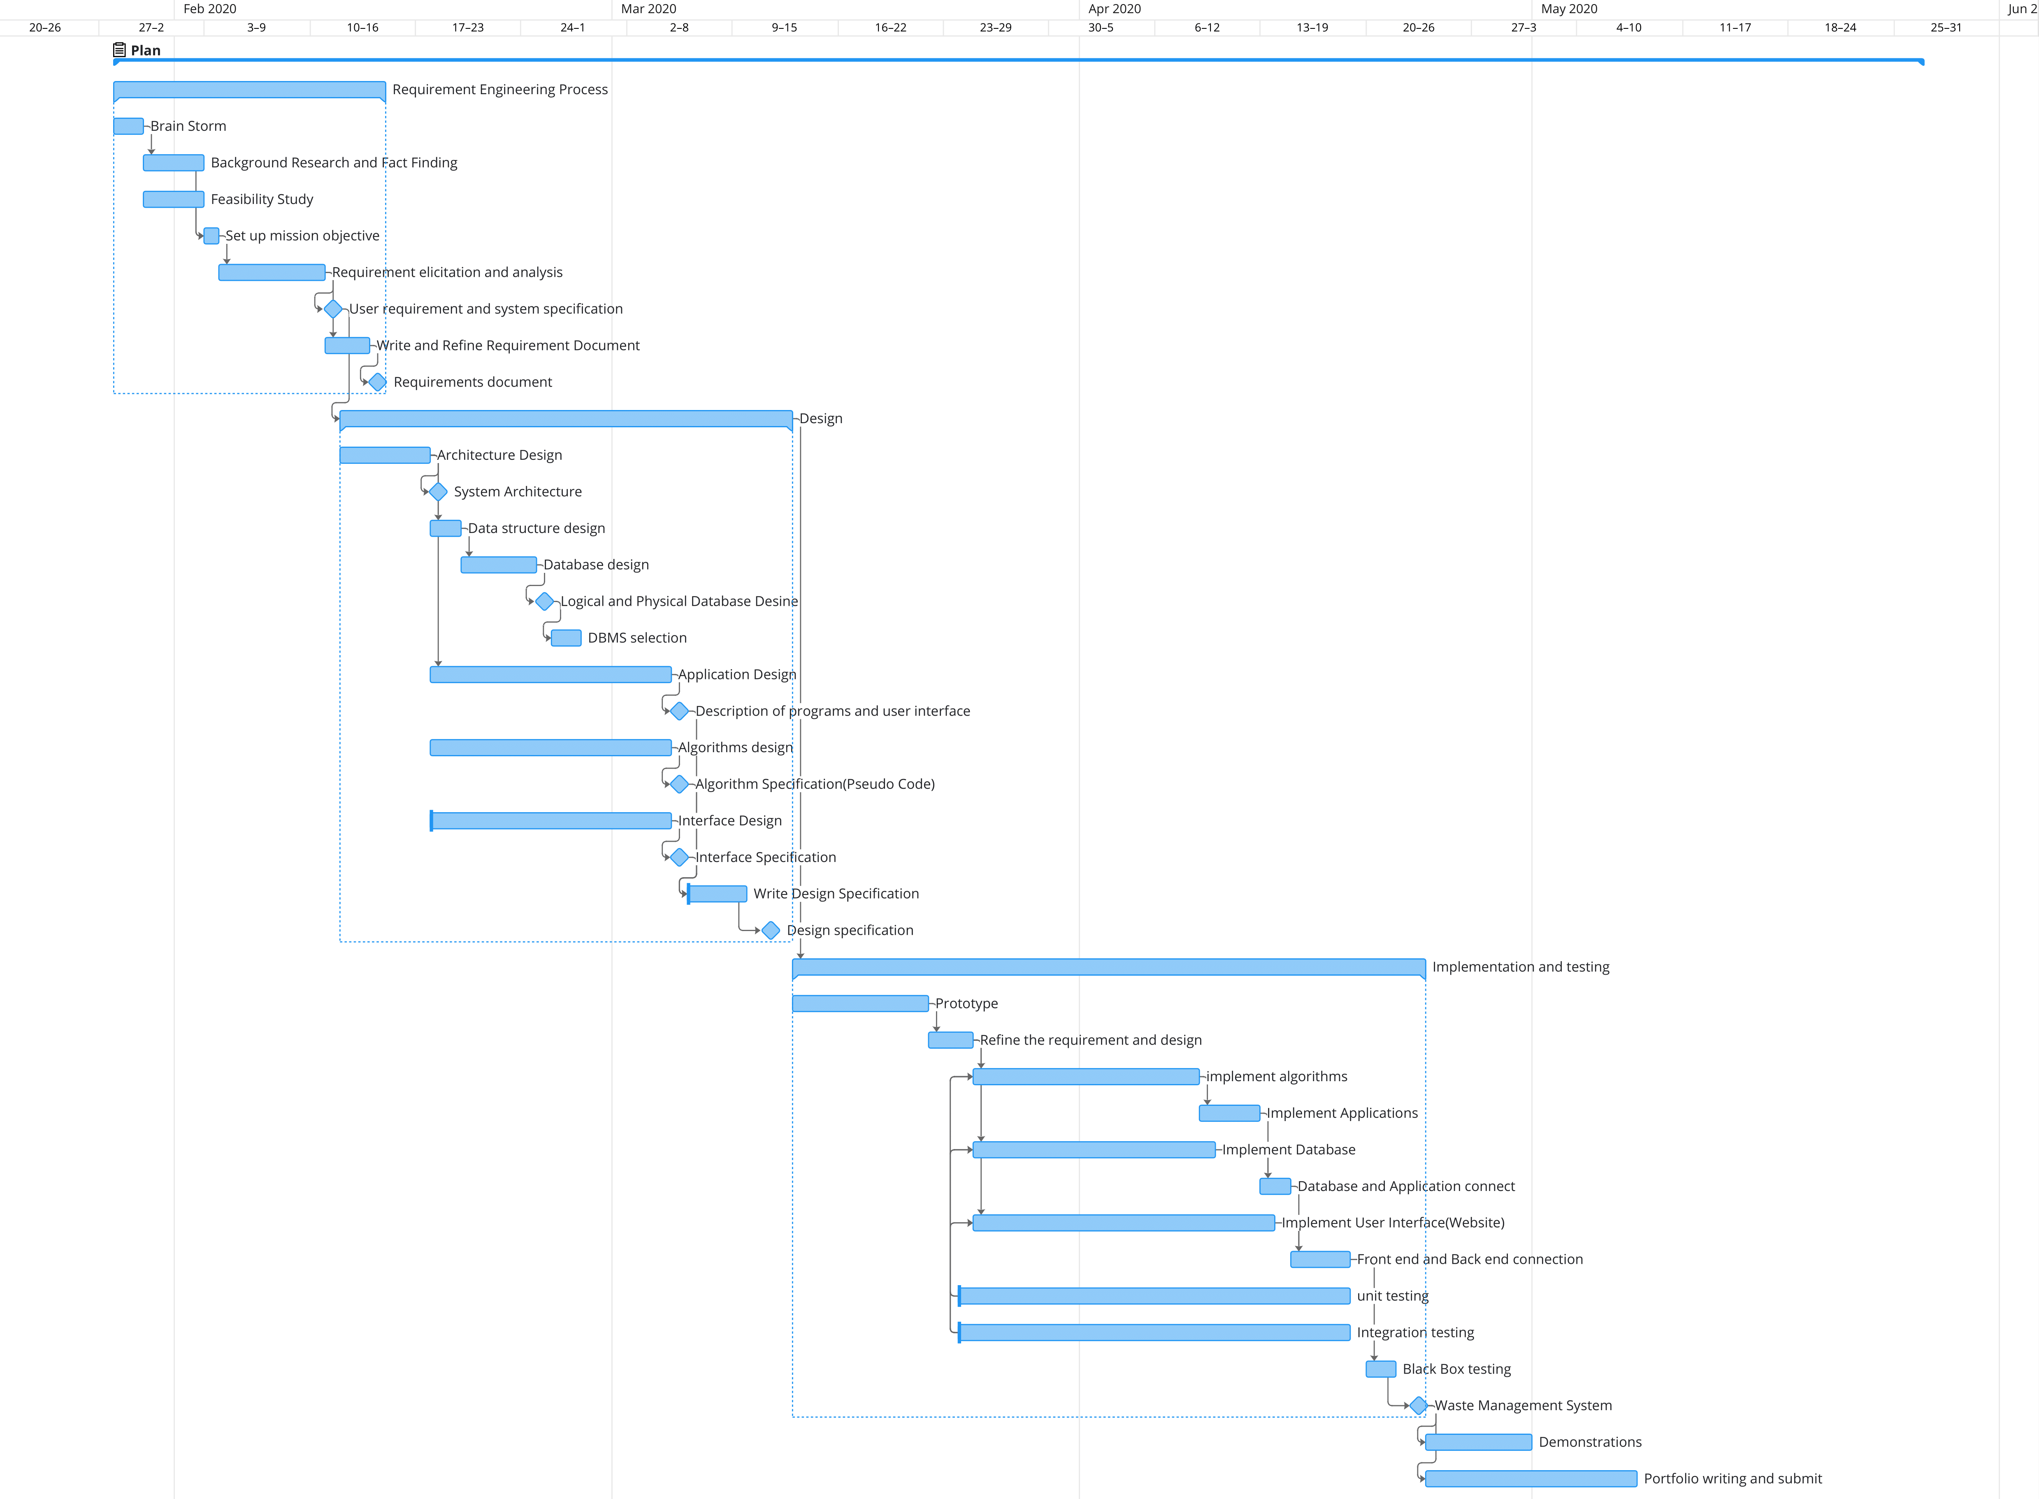

- J European Parliament and the Council of the European Union. Directive 2000/76/EC of the European Parliament and of the Council of 4 December 2000 on the incineration of waste. Official Journal of the European Communities 2000;L 332:91–111.

Figure 3: Gantt chart of plan

